Thermo-Couple
When two dissimilar conductors are joined by their two end that is known as thermo-couple. (Conductors should be different in thermo-couple and joints will be known as junction).
Seeback Effect: If two junctions of thermo-couple are placed at different temperature, then an emf will be produced in thermo-couple which will be proportional to the temperature difference. | 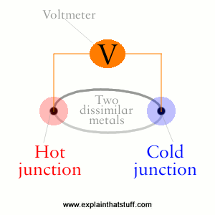
Peltier Effect: It is reverse of Seeback effect. According to this, when an electric current is passed through thermo-couple ,heat is evolved at one junction and absorbed at the other end i.e one end become hot while other become cold. The absorption and evolution of heat depends on the direction of flow of current. | 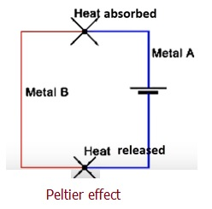

Thomson Effect: Heat is absorbed or produced when the current flows in material with a certain temperature gradient. The heat is proportional to both the electric current and the temperature gradient. This is called as "Thomson Effect". | 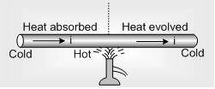

The major difference between Thomson effect and other two is that in Thomson effect we deal with only single metallic rod and not with thermo-couple as in Peltier effect and Seebeck effect. According to this effect, if a conductor has placed in varying temperature along its length and current is passed through it then it will absorb or evolve heat. Absorbing or evolving heat will depend on direction of current. Also, there are positive and negative Thomson effect as in Fig.

Seebeck effect
This effect was discovered by the German physicist Thomas Johann Seebeck in 1821.
In order to understand this effect, consider two wires of, say, copper and iron joined at their ends forming two junctions – Hot junction (P) and Cold junction (Q). A sensitive galvanometer (G) is also included in the circuit.
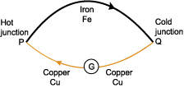
Seedback effect
The arrangement is called a Cu-Fe thermocouple. When one of the junctions is kept hot (P) and the other cold (Q) , a current begins to flow from Cu to Fe via the hot junction and from Fe to Cu via the cold junction. This current is called thermoelectric current. The flow of current implies the existence of emf in the circuit. This emf is known as thermoelectric emf.
A temperature difference of 100ºC between the two junctions produces a thermo emf of 0.0013 V in the Cu-Fe thermocouple.
The phenomenon of generation of electric current in a thermocouple by maintaining a thermal gradient (i.e. by keeping its two junctions at different temperatures) is called thermoelectric effect or Seebeck effect.
It is to be noted that Seebeck effect is reversible effect. It implies that on interchanging the hot junction and cold one, the direction of thermocouple current is reversed.
- Origin of thermo emf
In a thermocouple, electrons from a metal with greater electron density diffuse into the other with lower electron density establishing a small potential gradient. If the temperatures of the two junctions are same, the potentials will also be equal. But if one of the junction is heated, electron diffusion occurs and hence, potential at the hot junction becomes greater than the cold junction. So when a temperature difference exists between the two junctions, a thermo emf is produced.
- Thermoelectric series or Seebeck series
Seebeck discovered that the magnitude and direction of thermo emf in a thermocouple not only depends on the temperature difference between the two junctions, but also on the nature of the metals forming the thermocouple.
Seebeck studied the behaviour of pairs of metals organizing them into a series called Seebeck series or thermoelectric series.
Bi, Ni, Co, Pd, Pt, U, Cu, Mn, Ti, Hg, Pb, Sn,
Cr, Mo, Rn, Ir, Au, Ag, Zn, W, Cd, Fe, As, Sb.
Flow of current takes place from a metal that occurs earlier in the series to a metal occurring later in the series via the hot junction. For example, current flows from Cu to Fe via the hot junction.
The magnitude of thermo emf depends on the separation of metals in the series. Larger the separation between metals, greater is the thermo emf. It can be seen that Bi-Sb thermocouple is the best thermocouple, since the separation between the two is maximum.
- Variation of thermo emf with temperature
The thermo emf increases if the temperature of the hot junction is increased and the cold junction is kept constant.
In order to understand this concept, consider a copper-iron thermocouple with one junction (P) placed in hot oil bath and the other (Q) kept in ice. A sensitive galvanometer (G) is introduced in the circuit. A thermometer (T) is placed in the hot oil bath. The deflection in the galvanometer measures the thermo emf.
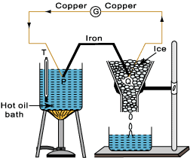
Variation of thermo emf with temperature

o Temperature Vs Thermo emf
A graph is plotted between temperature of the hot junction and thermo emf what is shown below.
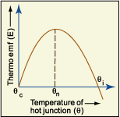
Graph: Temperature Vs Thermo emf
o
From the graph, it can be seen that as the temperature of the hot junction is increased, keeping the cold junction at constant temperature 0º C, the thermo emf increases with increase in temperature till it attains the maximum point.
The temperature of the hot junction, at which the thermo emf produced is maximum, is called neutral temperature. For a given thermocouple, neutral temperature is fixed and independent of the temperature of the cold junction. For Cu-Fe thermocouple, neutral temperature in 270ºC. Also when the temperature is increased further the neutral point, thermo emf starts decreasing and becomes zero. On heating further, the direction of thermo emf is reversed as what shown in the graph. It is due to the number densities and rates of diffusion of electrons in the two metals that are reversed.
The temperature of the hot junction at which the direction of thermo emf reverses, is called the temperature of inversion.
Also, we have the relation
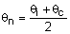
where Neutral temperature
Inversion temperature
Temperature of cold junction
For Cu-Fe thermocouple, if .
The neutral temperature depends on the material of the thermocouple. It is independent of the temperature of the cold junction and is constant for a thermocouple. On the other hand, the inversion temperature depends upon the temperature of the cold junction and the nature of materials forming the thermocouple.
o Relation between thermo emf and temperature of hot junction
When cold junction is maintained at 0ºC and the temperature of hot junction is varied, the graph of thermo emf versus temperature of hot junction is parabolic in nature. A simple relation between thermo emf (E) and temperature of hot junction is
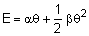
being thermoelectric constants. The values of for certain substances is shown below.
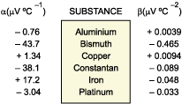
The values of for certain substances
o
- Thermoelectric power
Thermoelectric power is the rate of change of thermoelectric emf with temperature. It is also called Seebeck coefficient and is denoted by S.
We have
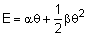
Thermoelectric power is
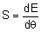
So, 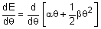
So, ...(i)
That is,
The graph between thermoelectric power and temperature is plotted below.
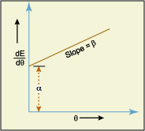
Graph: Thermoelectric power Vs Temperature
- When = 0, from equation (i)
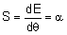 (intercept)
That is, the thermoelectric power is independent of the temperature of cold junction.
Also 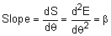
When , 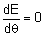
So from equation (i)
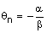...(ii)
Also when
So 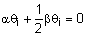
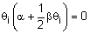
But
Hence, 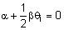
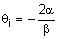
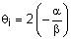
or ...(iii)
Peltier effect
In 1834, Jean Charles Althanase Peltier, a French watchmaker-turned scientist, discovered a thermoelectric effect that is converse of Seebeck effect. He found that if a source of emf is introduced in the Cu-Fe thermocouple so as to send the current through P, cooling is produced at P junction and heating at junction Q.
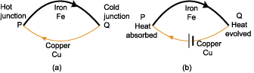
Peltier effect
The absorption or evolution of heat at a junction of two dissimilar metals when current is passed is called Peltier effect.
Peltier effect is reversible in nature. If the current direction were reversed, then at a given junction, where heat was evolved, it would be absorbed and vice versa.
The amount of heat absorbed or liberated per second at a junction when a unit current is passed through it, is known as Peltier coefficient. It is denoted by .
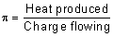
The SI unit of Peltier coefficient is .
If cold junction is at temperature and hot junction at temperature , then
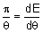
where dE is the thermo emf produced.
Also, 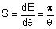...(i)
Peltier coefficient depends upon:
- nature of thermocouple
- charge passed.

 View Animation | Seebeck Effect (45 KB)
Comparison of Peltier effect and Joule effect
- In Peltier effect, heat is evolved at a junction while absorbed at the other. Joule effect is purely a heating effect (heat is evolved only).
- In Peltier effect, amount of heat absorbed or evolved is proportional to current. In Joule effect, amount of heat evolved is proportional to square of current.
- In Peltier effect, heating or cooling occurs only at the junction of two different metals whereas in Joule effect, heating takes place throughout the circuit.
- Peltier effect is reversible while Joule effect is irreversible.
Thomson effect
Another thermoelectric effect, rather hard to observe, was discovered by Thomson. He also proved that all three effects are the consequence of one basic phenomenon and are related to each other.
The absorption or evolution of heat along the length of a wire, when current is passed through it with one end kept hot and the other kept cold, is called Thomson effect. Thomson effect is reversible.
Thomson coefficient can be defined as the amount of heat energy absorbed or evolved per second between two points of a conductor having unit temperature difference, when unit current is passed. Thomson coefficient is represented by
If is the temperature difference between the same two points of rod, and dV is the potential difference between the points of a metal rod. Then, the Thomson coefficient is
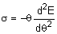
Seebeck coefficient is

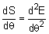
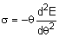
or 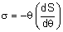
Applications of thermoelectric effects
- Measurement of temperature
A thermocouple is used to measure temperature in industries and laboratories.
A thermocouple of two different metals like copper and constantan is taken with its one junction in contact with the region whose temperature needs to be determined while the other junction is kept in ice. The thermo emf, so produced, is measured from the calibration curve against the thermo emf. Copper-constantan thermo couples are suitable for the range 50 K – 400 K. For higher temperatures (1500 K – 2000 K), thermocouples of platinum with platinum rhodium alloys are used.
- Detection of heat radiation
A thermopile consists of a large number of thermocouples in line (series) and can be used in the detection of heat radiation.
- Thermoelectric refrigerator
When current passes through a thermocouple, owing to Peltier effect, heat is evolved at one junction and absorbed at the other. If on the whole, heat is removed from the working volume, the thermocouple serves as a thermoelectric refrigerator.
- Thermoelectric generator
By placing one junction in a flame and exposing the other to air, thermocouples can be used to generate thermoelectric power.
Points to remember
- The phenomenon of generation of electric current in a thermocouple by maintaining a thermal gradient (i.e. by keeping its two junctions at different temperatures) is called thermoelectric effect or Seebeck effect.
- Seebeck effect is reversible effect.
- Temperature difference exists between the two junctions is the origin of thermo emf.
- Seebeck discovered that the magnitude and direction of thermo emf in a thermocouple not only depends on the temperature difference between the two junctions, but also on the nature of the metals forming the thermocouple.
- Flow of current takes place from a metal that occurs earlier in the Seebeck series to a metal occurring later in the series via the hot junction.
- The thermo emf increases with increase in temperature till it attains the maximum point.
- The temperature of the hot junction at which the direction of thermo emf reverses, is called the temperature of inversion.
- Peltier effect is reversible effect.
- Thomson effect is reversible.

